In machine learning, particularly in the context of computer vision, image processing is a crucial step that prepares raw image data for analysis and model training. Here’s a comprehensive overview of the key image processing steps commonly used:

Preprocessing

1. Image Acquisition
- Source: Images can be captured from various sources like cameras, sensors, or retrieved from databases.
- Formats: Images may come in different formats (JPEG, PNG, TIFF, etc.) and resolutions.

2. Preprocessing
- Resizing: Adjusting image dimensions to fit the model’s input size or standardize images.
- Normalization: Scaling pixel values to a specific range, often [0, 1] or [-1, 1], to improve model performance.
- Cropping: Cutting out specific areas of the image to focus on regions of interest.
- Color Space Conversion: Changing the color representation (e.g., RGB to grayscale or HSV) depending on the task.

3. Noise Reduction
- Filtering: Applying filters like Gaussian blur, median filter, or bilateral filter to reduce noise and smooth the image.
- Denoising Algorithms: Techniques like Non-Local Means or wavelet denoising to remove unwanted noise.

4. Enhancement
- Contrast Adjustment: Enhancing the contrast to make features more distinguishable.
- Histogram Equalization: Improving the image contrast by spreading out the intensity levels.

5. Feature Extraction
- Edge Detection: Using methods like Canny, Sobel, or Laplacian filters to find edges and boundaries.
- Texture Analysis: Identifying texture patterns using techniques like Local Binary Patterns (LBP).
- Feature Descriptors: Extracting features like SIFT (Scale-Invariant Feature Transform) or SURF (Speeded-Up Robust Features).

6. Segmentation
- Thresholding: Separating objects from the background based on pixel intensity.
- Region-Based Segmentation: Dividing the image into regions based on similarities in texture or color.
- Clustering Methods: Applying algorithms like k-means to segment the image into clusters.
- Semantic Segmentation: Classifying each pixel into a category using methods like U-Net or Mask R-CNN.

7. Transformation and Augmentation
- Geometric Transformations: Applying transformations like rotation, scaling, translation, and flipping.
- Data Augmentation: Generating variations of the image (e.g., rotations, shifts, and color changes) to increase the diversity of training data.

8. Detection and Localization
- Object Detection: Identifying and locating objects within an image using methods like YOLO (You Only Look Once) or SSD (Single Shot MultiBox Detector).
- Bounding Boxes: Drawing bounding boxes around detected objects.

9. Post-processing
- Morphological Operations: Applying operations like dilation, erosion, opening, and closing to refine segmented regions.
- Filtering and Smoothing: Further refining the image or extracted features.

10. Dimensionality Reduction
- PCA (Principal Component Analysis): Reducing the number of features while retaining important information.
- t-SNE (t-Distributed Stochastic Neighbor Embedding): Visualizing high-dimensional data in lower dimensions.

11. Feature Engineering and Selection
- Creating Features: Developing new features from raw image data based on domain knowledge.
- Selecting Features: Choosing the most relevant features to improve model performance and reduce complexity.

12. Model Training and Evaluation
- Training: Using preprocessed images to train machine learning or deep learning models.
- Validation and Testing: Evaluating model performance on unseen data to ensure generalization.

13. Deployment and Inference
- Optimization: Ensuring the model runs efficiently on production hardware.
- Inference: Using the trained model to make predictions on new images.

2. Preprocessing techniques:

1. Resizing
Purpose: Standardizes the size of images to fit the input requirements of a model or to reduce computational load.
- Scaling: Adjusting image dimensions by a fixed factor. For example, resizing an image from 1024x768 to 256x256.
- Aspect Ratio: Maintaining the image’s original aspect ratio to prevent distortion. This might involve padding to fill the new dimensions without stretching the image.
- Interpolation Methods:
  - Nearest Neighbor: Simple and fast but can produce blocky images.
  - Bilinear: Considers the closest four pixels to calculate the new pixel value, smoother than nearest neighbor.
  - Bicubic: Uses 16 pixels to compute new values, providing high-quality resizing with less blurring.

2. Normalization
Purpose: Adjusts the pixel values to a consistent range, which can improve model performance and convergence.
- Pixel Value Range: Typically normalized to [0, 1] by dividing pixel values by 255 (for 8-bit images) or to [-1, 1] by scaling and shifting.
- Mean and Standard Deviation Normalization: Subtracting the mean and dividing by the standard deviation of pixel values, especially useful when working with deep learning models that are sensitive to pixel value distributions.

3. Cropping
Purpose: Focuses on specific regions of interest within an image, often to reduce the amount of irrelevant data or to highlight important features.
- Center Cropping: Cropping from the center of the image, commonly used to standardize input sizes.
- Random Cropping: Extracting random portions of the image during training to introduce variability and improve generalization.
- Fixed Cropping: Specifying exact coordinates or sizes for the crop, useful when the region of interest is known in advance.

4. Color Space Conversion
Purpose: Converts the image from one color representation to another based on the task requirements or computational efficiency.
- Grayscale: Converts RGB images to single-channel images representing shades of gray. Useful for tasks where color information is not needed.
- HSV (Hue, Saturation, Value): Separates color (hue) from intensity (value), which can be useful for tasks involving color-based segmentation.
- LAB: Separates lightness from color components, useful in tasks requiring perceptual uniformity (i.e., colors that look evenly spaced to the human eye).

5. Image Denoising
Purpose: Removes unwanted noise from images to improve the quality and clarity, making it easier for models to extract features.
- Gaussian Blur: Applies a Gaussian filter to smooth the image and reduce noise.
- Median Filter: Replaces each pixel value with the median value of its neighboring pixels, effective at removing salt-and-pepper noise.
- Bilateral Filter: Maintains edges while reducing noise, useful for preserving important details.

6. Histogram Equalization
Purpose: Enhances the contrast of an image by spreading out the intensity levels, making features more distinguishable.
- Global Histogram Equalization: Adjusts the entire image based on its histogram.
- Adaptive Histogram Equalization: Applies histogram equalization in localized regions, improving contrast in different parts of the image.

7. Data Augmentation
Purpose: Creates variations of images to improve model robustness and generalization by artificially expanding the training dataset.
- Rotation: Rotating images by small angles to help the model become invariant to orientation.
- Translation: Shifting images horizontally or vertically.
- Flipping: Horizontal or vertical flipping to introduce variability.
- Zooming: Cropping and resizing to simulate zoomed-in effects.
- Brightness/Contrast Adjustments: Varying brightness or contrast to make the model robust to lighting conditions.

8. Affine Transformations
Purpose: Applies linear transformations to adjust the geometric properties of the image.
- Rotation: Rotating the image around a point.
- Scaling: Resizing the image proportionally.
- Shearing: Applying a shearing effect to slant the image.
- Translation: Moving the image along the x and y axes.

9. Edge Enhancement
Purpose: Enhances the edges within an image to make features more distinct.
- Sharpening: Applying filters (e.g., Laplacian) to enhance edges and fine details.
- Edge Detection: Techniques like the Sobel or Canny edge detector highlight boundaries and transitions in pixel intensity.

3. pixel value
A pixel value refers to the data associated with a single pixel in an image. This data represents the color or intensity of that pixel and is essential for determining how an image appears when displayed or processed. Here’s a detailed explanation:

1. Definition of Pixel Value
- Pixel: The smallest unit of an image, which contains information about color or intensity. An image is made up of a grid of pixels.
- Value: The specific data for each pixel, which dictates its color or brightness.

2. Types of Pixel Values
Pixel values vary depending on the color model and the type of image. Here are common types:

a. Grayscale Images
- Pixel Value: Represents the intensity of light, with values typically ranging from 0 (black) to 255 (white) in 8-bit images.
- Example: A pixel value of 128 represents a medium gray.

b. Color Images (RGB)
- Pixel Value: Consists of three components—Red, Green, and Blue (RGB). Each component is typically an 8-bit value, ranging from 0 to 255.
- Example: A pixel value of (255, 0, 0) represents pure red.

c. Other Color Models
- HSV (Hue, Saturation, Value): Pixels are represented by hue (color type), saturation (color intensity), and value (brightness).
- LAB (Lightness, A, B)**: Pixels are represented by lightness and two color components that describe colors.

3. Representation and Storage
- 8-bit Images: Each pixel value is stored as an 8-bit integer, allowing for 256 possible values (0-255).
- 16-bit Images: Each pixel value is stored as a 16-bit integer, allowing for 65,536 possible values (0-65,535), used in high-dynamic-range imaging.
- Floating-Point Images: Pixel values can also be represented as floating-point numbers for more precise color and intensity information, often used in scientific imaging.

4. Example in Practice

Grayscale Image
A simple 3x3 grayscale image might look like this:
100 | 150 | 200
50 | 75 | 125
0 | 25 | 50
Each cell represents a pixel value, with 0 being black and 255 being white. The values in between represent various shades of gray.

RGB Image
A small 2x2 RGB image might be represented as follows, where each pixel value is a tuple of (R, G, B):
(255, 0, 0) | (0, 255, 0)
(0, 0, 255) | (255, 255, 0)
- The first pixel is pure red.
- The second pixel is pure green.
- The third pixel is pure blue.
- The fourth pixel is yellow (red + green).

5. How Pixel Values Are Used
- Display: When an image is displayed, the pixel values are translated into colors or intensities on a screen.
- Processing: Image processing algorithms manipulate pixel values to achieve effects like blurring, sharpening, or object detection.
- Compression: Techniques like JPEG or PNG compression reduce the amount of data needed to store the pixel values without significantly affecting image quality.

What is Interpolation?
Interpolation is a method used to estimate new pixel values when resizing an image. When you resize an image, you often need to add new pixels or modify existing ones. Interpolation helps in estimating these pixel values based on the values of neighboring pixels.
Here's a simplified breakdown:
- Original Pixels: Your image has a certain number of pixels with specific values (colors or intensities).
- Resizing: When you resize the image, you either need to create new pixels (increasing size) or determine the values of existing pixels (decreasing size).
- Interpolation: This process estimates the values of these new or modified pixels.

Types of Interpolation Methods
- Nearest Neighbor Interpolation
Description: The simplest and fastest method. It assigns the value of the nearest pixel to the new pixel.
How It Works:
  - Find the nearest original pixel to the new pixel location.
  - Copy the value of the nearest pixel to the new pixel.
Pros: Fast and easy to implement. Cons: Can produce blocky or pixelated images, especially noticeable with larger resizing.
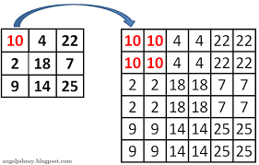

2. Bilinear Interpolation
Description: A more sophisticated method that considers the closest four pixels to compute the new pixel value.
How It Works:
- Determine the four nearest pixels surrounding the new pixel.
- Calculate the weighted average of these four pixels based on their distance from the new pixel.
Pros: Produces smoother images compared to Nearest Neighbor. Cons: Slightly more computationally intensive.
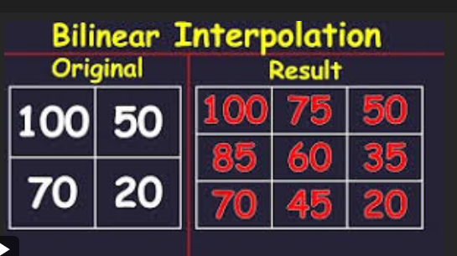

3. Bicubic Interpolation
Description: An advanced method that uses the closest 16 pixels (4x4 grid) to calculate the new pixel value.
How It Works:
- Collect the 16 nearest pixels surrounding the new pixel.
- Calculate a weighted average of these 16 pixels using cubic polynomials.
Pros: Provides high-quality results with smoother transitions and less blurring compared to Bilinear. Cons: More computationally intensive, slower to compute.\
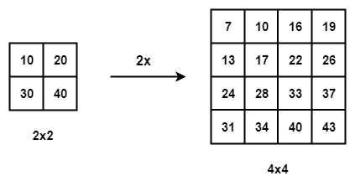

4. Color Space Conversion
that explains the purpose and different types of color space conversions, focusing on Grayscale, HSV, and LAB color spaces.

Grayscale
Converts the image from one color representation to another based on the task requirements or computational efficiency.
To adjust the image’s color representation to better suit specific processing tasks.

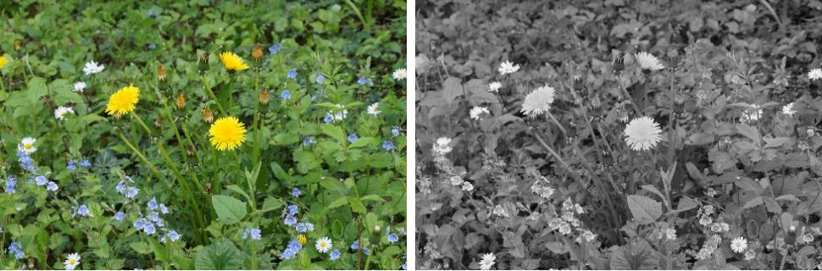

HSV.
HSV (Hue, Saturation, Value)
Separates an image into three components: Hue (color type), Saturation (color intensity), and Value (brightness). This allows independent manipulation of color components.
Useful for color-based segmentation and filtering, as it separates the color information from intensity.

The HSV (Hue, Saturation, Value) color space corresponds better to how people experience color than the RGB color space does. For example, this color space is often used by people who are selecting colors, such as paint or ink color, from a color wheel or palette.
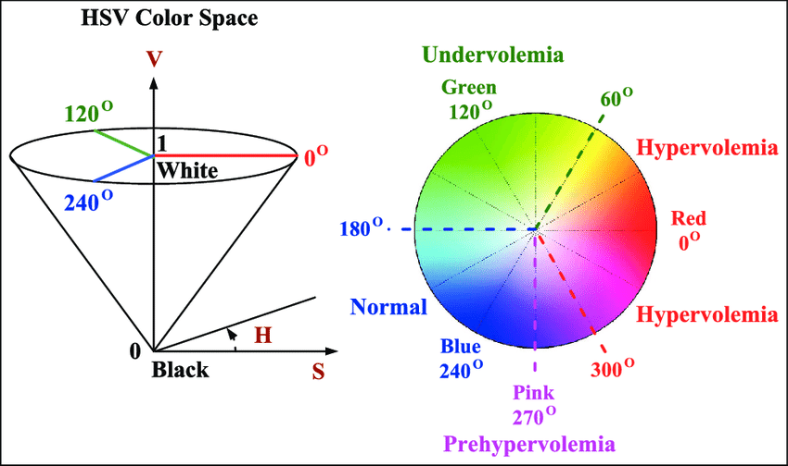

LAB (Lightness, A, B)**
Separates lightness (L) from color components (A* and B*). The A* component represents the green to red color axis, and B* represents the blue to yellow color axis.
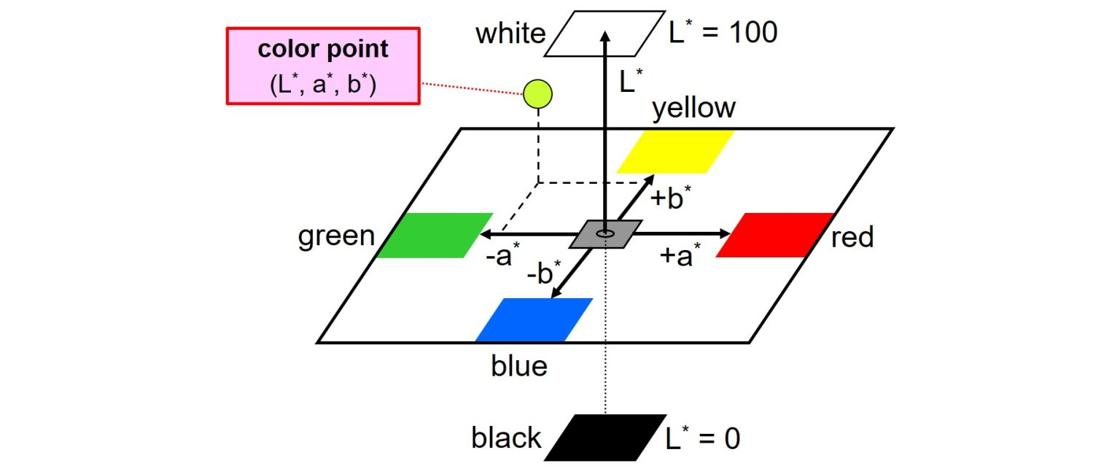
Useful in tasks requiring perceptual uniformity, where colors that appear evenly spaced to the human eye need to be processed.

5. Image Denoising
this effect is often compared to the "grain" seen in film photography or the static seen on a poorly tuned TV screen. Here’s a more detailed breakdown of what a grainy appearance means:
Noise in images refers to random variations in pixel values that distort the original signal, degrading image quality. Different types of noise are characterized by their statistical properties and visual effects. Here's an overview of common types of noise found in images
Images appear grainy with random variations in pixel intensity.

1. Gaussian Noise
Imagine: You have a photo, and if you look closely, it looks like someone sprinkled a bit of gray dust all over it. The dust is scattered randomly, with some areas having more dust and others less.
In Simple Terms: Gaussian noise is like a random, grainy texture that makes your image look a bit fuzzy or speckled. It's like a static effect you might see on a TV screen.

2. Salt-and-Pepper Noise
Imagine: You’re looking at a photo of a beautiful scene, but it looks like someone threw a bunch of white and black pepper grains on it. There are random white and black spots all over the image.
In Simple Terms: Salt-and-pepper noise looks like random black and white dots scattered throughout the image. It's like someone spilled salt and pepper on the picture.

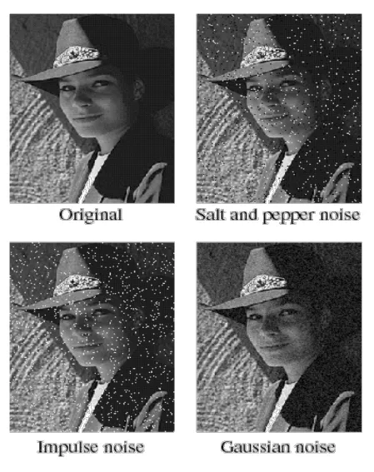

1. Gaussian Blur Filter
Purpose: Smooth out high-frequency noise by averaging pixel values in a local neighborhood using a Gaussian function.
How It Works:
- Each pixel in the image is replaced by a weighted average of its neighboring pixels.
- The weights are determined by a Gaussian function, which gives more importance to pixels close to the center.
Visual Example:
- Picture smoothing out a rough surface with a soft, blurred effect.
Pros:
- Effective for reducing Gaussian noise and smoothing the image.
- Simple and fast to compute.
Cons:
- Can blur important details and edges in the image.

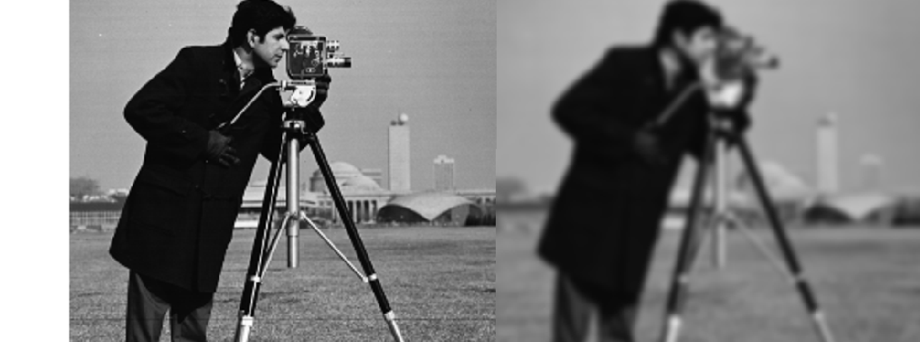

2. Median Filter
Purpose: Remove salt-and-pepper noise by replacing each pixel’s value with the median value of its neighboring pixels.
How It Works:
- For each pixel, a neighborhood around it is examined, and the pixel value is replaced by the median of the values in this neighborhood.
Visual Example:
- Imagine removing random dots by picking the most common value among neighboring pixels.
Pros:
- Effective for removing salt-and-pepper noise without blurring edges as much.
Cons:
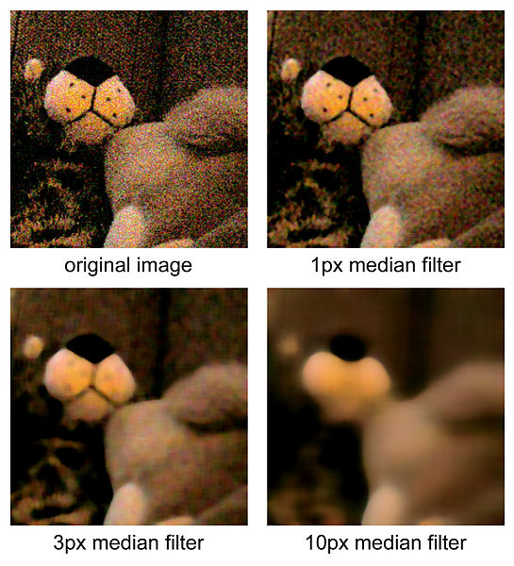
- May not be as effective for Gaussian noise.

3. Bilateral Filter
Purpose: Reduce noise while preserving edges by considering both spatial distance and color similarity.
How It Works:
- Each pixel is replaced by a weighted average of its neighbors, with weights depending on both spatial distance and color difference.
- This helps preserve edges while smoothing out noise.
Visual Example:
- Think of smoothing out an image while keeping sharp edges, like blurring a photo but not the text.
Pros:
- Preserves edges and details better than Gaussian blur.
Cons:
- More computationally intensive than Gaussian blur.
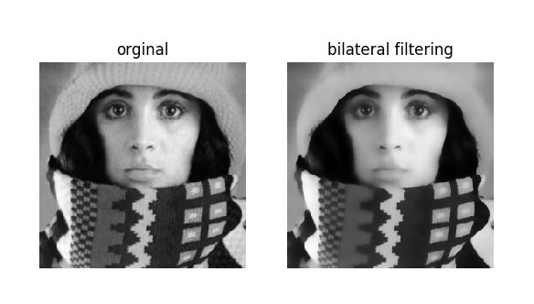

4. Non-Local Means Denoising
Purpose: Remove noise by averaging similar patches from the entire image, not just local neighborhoods.
How It Works:
- For each pixel, it compares its surrounding patch to patches across the image. Similar patches are averaged to reduce noise.
Visual Example:
- Imagine comparing each part of the image to every other part to find similar patterns and average them out.
Pros:
- Highly effective for preserving textures and details while removing noise.

5. Wavelet Denoising
Purpose: Reduce noise by transforming the image into the wavelet domain, thresholding the coefficients, and then transforming it back.
How It Works:
- The image is transformed into wavelet coefficients, which are then thresholded to reduce noise. The image is reconstructed from the modified coefficients.
Visual Example:
- Think of removing noise from an image by working in a transformed space where you can isolate and remove noise more easily.
Pros:
- Effective for various types of noise while preserving image details.
Cons:
- More complex to implement and understand.
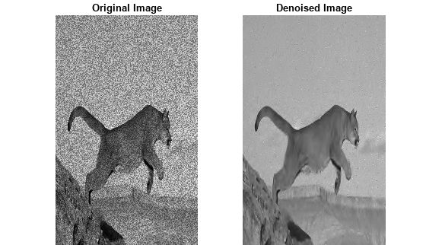
Histogram Equalization is a technique used to enhance the contrast of an image by redistributing the intensity levels. This makes the features in an image more distinguishable. Here's a simple breakdown of the two main types of histogram equalization:

Types of Histogram Equalization

1. Global Histogram Equalization
Imagine: You have a photo of a landscape that is too dark overall. Global Histogram Equalization is like adjusting the brightness and contrast for the whole photo at once. It’s a one-size-fits-all approach.

2. Adaptive Histogram Equalization (AHE)
Imagine: You have a photo of a room with both bright windows and dark corners. Adaptive Histogram Equalization works on smaller sections of the photo, like fixing the brightness of each corner separately rather than the whole room at once.
